Lightning Test for Jones Stephens Brand Pex-Al-Pex Gas Piping and Fittings System (manufactured by Valsir in Italy)

Test and Test Facility:

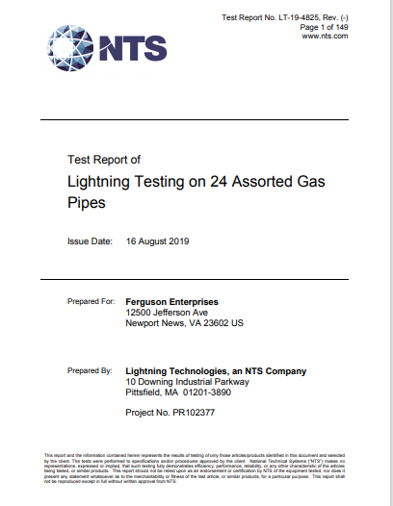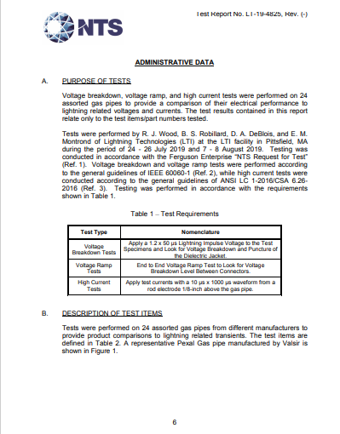
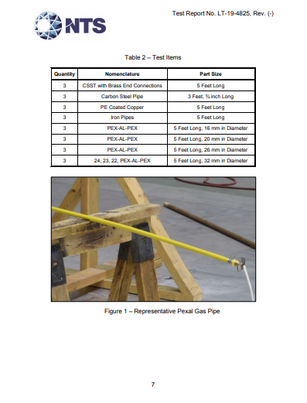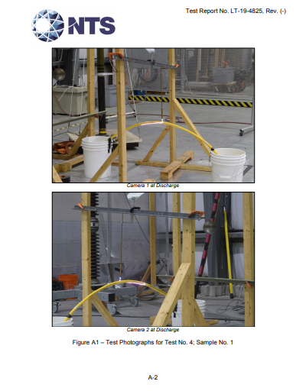

List of test components:
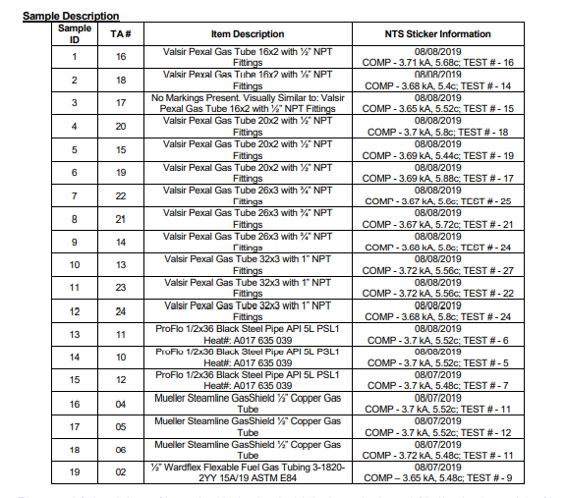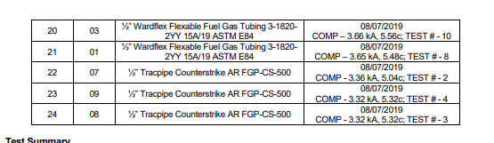

Example of Steel Pipe (top) and copper pipe (below)
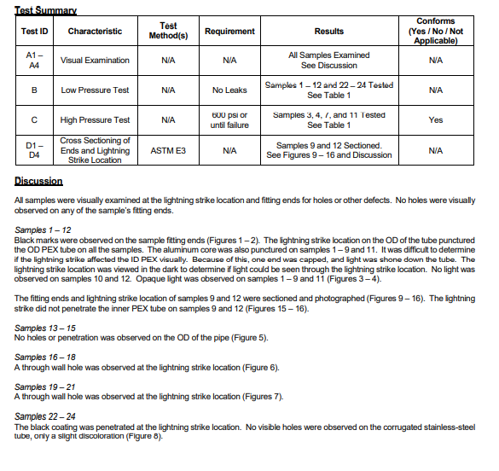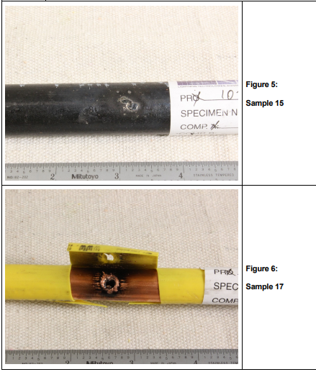

Example of CSST (Wardflex top, Counterstrike bottom) Worst case for Valsir Pex-Al-Pex (hole in outer pex and aluminum, but inner pex held pressure up to 600 PSI)
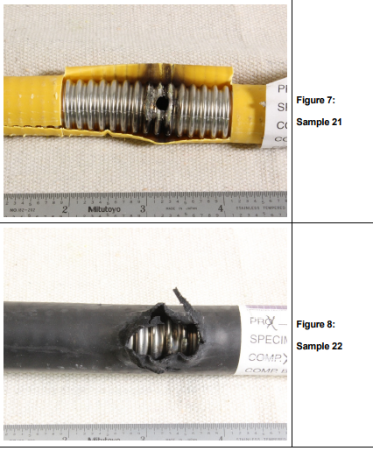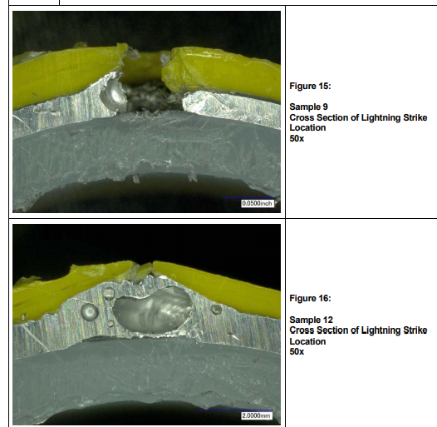

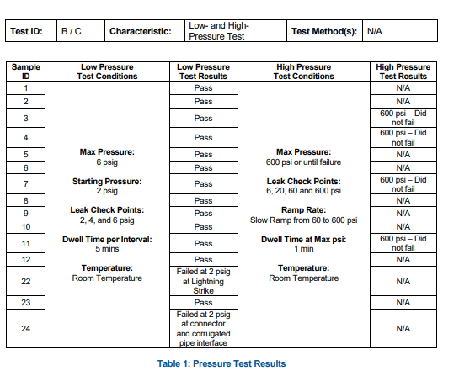

Conclusion:

After identical simulated lighting strikes on each of these piping samples,
- All Valsir Pex-Al-Pex piping (samples 1-12) passed, held pressure up to 600 PSI (limit of test equipment)
- All Steel pipe (samples 13-15) passed
- All Copper pipe (samples 16-18) failed with visible holes
- All Wardflex brand CSST (samples 19-21) failed with visible holes
- All Omega Flex Counterstrike brand CSST (Samples 22-24) showed black coating penetration but no visible holes, then 2 of the 3 samples failed to hold pressure at 2 PSIG

